PROCESSES

* OS supports the ability to have cocurrent operation (pseudo) even when there is only one CPU available. Switching the CPU between processes quickly, OS can make the computer more productive.
* A process is sequential stream of execution and its own address space.
* Program is a static entity, whereas the process is an active one.
* There are two parts of process:
  + Sequential execution: no concurrency inside a process (there’s only one CPU and one physical program counter)
  + Process state: everything that process interacts with.

The process model:

1. Single-processor systems (pseudo-parallelism)
2. Multiprogramming

Switching among processes.

1. A single processor may be shared among several processes.

Scheduling algorithm

1. Context switch

* Switching to another process requires saving the old state and loading the new process.
* Context switch time is pure overhead.
* Has become a performance bottle neck

THE PROCESS CREATION

4 principal events cause processes to be created:

1. System initialization.
2. Execution by a running process.
3. A user request to create a new process.
4. Initiation of a batch job.

Automatically by the system

* At the system initialization
* Foreground (app) and background (service) processes.

By another process:

* A system call for process creation
* Situations:
  + Needs help doing some computation
  + User action – interaction with the shell.

Daemon: the process that stay in the background to handle some activity.

THE PROCESS HIERARCHIES

Process hierarchy:

* Parent-child relationship
* The child can itself create new processes.
* Tree of processes.

In UNIX OS: A process creates processes, process group

In Windows OS: all processes are equal (has no concept of process hierarchy). Parent is given a special token (handle) that can use to control the child.

THE PROCESS TERMINATION

* Normal exit -> voluntary
* Error exit. -> voluntary
* Fatal error -> involuntary
* Killed by another process. -> involuntary

🡺Voluntary – using a special system call

🡺Involuntary – receiving an interruption.

THE PROCESS STATE

* Running
* Ready
* Blocked
* New (optional)
* Terminated (optional)

Transition State:

1. NEW to READY or RUNNING
2. READY to RUNNING (dispatch)
3. RUNNING to READY (interrupt)
4. RUNNING to BLOCKED (block)
5. BLOCKED to READY (ready)
6. RUNNING to TERMINATAED (exit)

OS maintains processes as a table, each process is a block PCB(Process Control Block).

PCB contains all information that need:

* ID
* State
* Value of CPU register
* Scheduling information
* Memory management
* Accounting
* I/O status
* Parent id, process group…

Some exercises:

**CPU utilization = 1 - pn**

* + A computer has 512MB of memory, with OS taking 128 MB and each user program also taking up 128MB with an 80% average I/O wait
    - CPU utilization = 1 – 80%((512-128)/128) = 49%

THREADS

* Threads are simply miniprocesses in process.
* Threads describe a sequential execution within a process.
* Share the same address space and resources.
* No protection between threads.
* Lightweight processes.
* Have its own stack
* Multithreading (many threads in same process).

Muiltithread is analogous (tương tự) to have multiple processes.

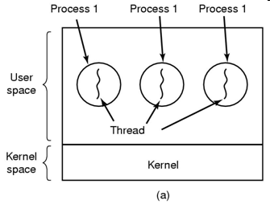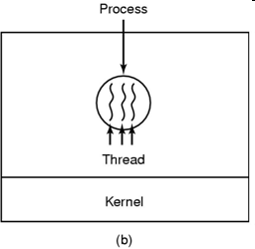

Benefits:

* Responsiveness and better resource sharing.
* Economy: take less time to create a new thread than a process
* Useful on system with multiple CPUs.
* Less time to terminate a thread than a process.
* Less time to switch between 2 threads within the same process.
* Communicate with each other without invoking the kernel.

MULTITHREADING

* MS-DOS supports a single thread
* UNIX support multiple processes but only supports one thread per process.
* Windows 2000, Solaris, Linux, OS support multiple threads.
* Multithread is effective in multiprocessors because the thread can execute in concurrently.

IMPLEMENTING THREADS IN USER SPACE

* We can implement thread using user-level library.
* The kernel knows nothing about threads.
* The reads run on top of a runtime system.
* Each process has its own thread table.

Advantages:

* Switching and scheduling faster.
* Each process can have its own customized scheduling algorithm.
* Scale better.

Disadvantages:

* The implementation of blocking system calls is complexity 🡪 instead of blocking thread, the process is blocked.
* Thread voluntarily gives up the CPU 🡪 entire process is blocked. (Cái này một thằng bị mà cả đám bị kill, đéo hiểu)
* Make system call constantly because dev want threads precisely in applications.

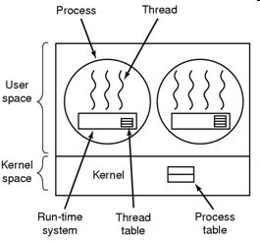

IMPLEMENTING THREADS IN THE KERNEL

The kernel knows about threads and manage them. (no need runtime-system)

Kernel schedules all the threads.

Kernel has a thread table.

Advantages:

* Kernel can switch between threads.
* No problem with blocking system calls.
* Use if multiprocessor support is available. (multiple CPUs).

Disadvantages:

* Greater cost ->> Solution: recycling
* Thread creation, saving is slow.

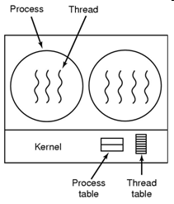

LIBRARY in THREADS:

There are 3 primitive libraries:

* POSIX Pthreads.
* Win32 threads.
* Java threads.

On Windows system, JAVA threads are implemented using the Win32 API.

UNIX often use Pthreads.

Hybrid Implementations

🡪 combine advantages of user-level and kernel-level.

* Using kernel-level threads and then multiplex user-level threads onto some or all the kernel threads.
* 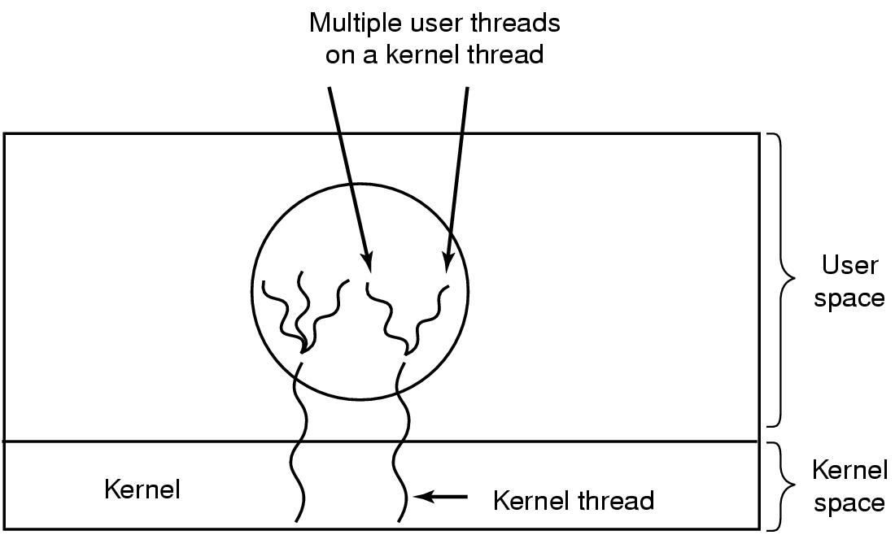

Scheduler Activations

Context:

* Kernel better than user level (but slower)
* When a thread is blocked, other threads can run
* Avoiding unnecessary transitions between user mode and kernel mode.
* The user mode can block the thread and schedule a new one.

Upcall:

* The notified signal with information is used to activate runtime system.

**Scheduler Activation mechanism**

* When thread has blocked, the kernel make the upcall to the process’s runtime system.
* The usermode can reschedule its threads by:
  + Marking the current thread as blocked.
  + Taking another thread from ready list, loading and restarting.
* When the blocked thread is ready and can run again, the kernel make another upcall.
* The runtime system can either restart the blocked thread immediately or put in on the ready list to be run later.

**Scheduler Activation: are to mimic the functionality of kernel threads but with the better performance and greater flexibility. 🡪 reducing transition.**

**InterProcess Communication (IPC)**

* Race condition: a situation where several threads (or processes) manipulate the same data concurrently.
* Prevent race condition:
  + No two processes simultaneously.
  + No assumptions.
  + No process running outside.
  + No process should have to wait forever.
* Critical Regions: the part of program where the shared memory is accessed.
* Mutual Exclusion: one thread is executing in its critical section and no other threads can be executing.
  + Disabling interrupts is often a useful technique within the OS itself but is not appropriate for user processes

Schedule Algorithm

Non-preemptive:

* Picks a process to run and then just lets it r**un until it blocks or until it voluntarily releases** the **CPU** (will not be forceably suspended, no scheduling decisions)
* Once a process is in the running state, it will **continue until it terminates or blocks itself for I/O**
* **Applying** to the **batch** system

Preemptive:

* The process can **run** (continuously) for a **maximum** of some **fixed time**. If it is still running at the end of this time, it is **suspended** **and** the **scheduler** will **pick** **another** process **to** **run** (needs timer)
* Currently running process may be **interrupted** and **moved** **to** the **Ready state** by the operating system
* Allows for better service since any one process **cannot monopolize the processor for very long**
* **Applying** to the **time-sharing or real time**

Criteria/Properties Term

* Fairness
* Policy enforcement
* Throughput = the number of processes that complete their execution/time unit
* Turnaround time = amount of time to execute a particular process, sum of the periods spent waiting; the time from the process is submitted until it’s completed (arrival time)
* CPU utilization = keep the CPU as busy as possible.
* Response time
* Proportionality

Categories:

* Batch:
  + Non-preemptive
  + Preemptive with long time periods
  + Reduces processes switches and increase performance
* Interactive
  + Preemptive
* Real-time
  + Preemption

All systems: Fairness, policy enforce, balance

Batch: throughput, turnaround, cpu util

Interactive: response time, proportionality

Real-time: meeting deadline, predictability

**Algorithms**

**First Come First Served (FCFS) 🡪 simplest**

* Non preemptive
* Enter the ready state first, get the CPU first and hold until it’s blocked.
* Exercise: P2: 3, P3: 3, P1: 24

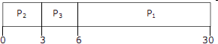

P1 = 6, P2 = 0, P3 = 3

Average waiting time: (6+0+3)/3=3

Average turnaround time: (6+3+30)/3=13

Shortest Job First (SJF)

* Non preemptive
* Pick the shortest job first.
* Optimal algorithm for the jobs are available simulta…
* Exercise: P1:6, P2:8, P3:7, P4:3

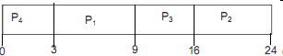

AVG Waiting time: (0+3+9+16)/4

AVG turnaround time: (3+9+16+24)/4

Shortest Remaining Time Next (SRT)

* Preemptive

Round-Robin Scheduling (RR)

* Preemptive

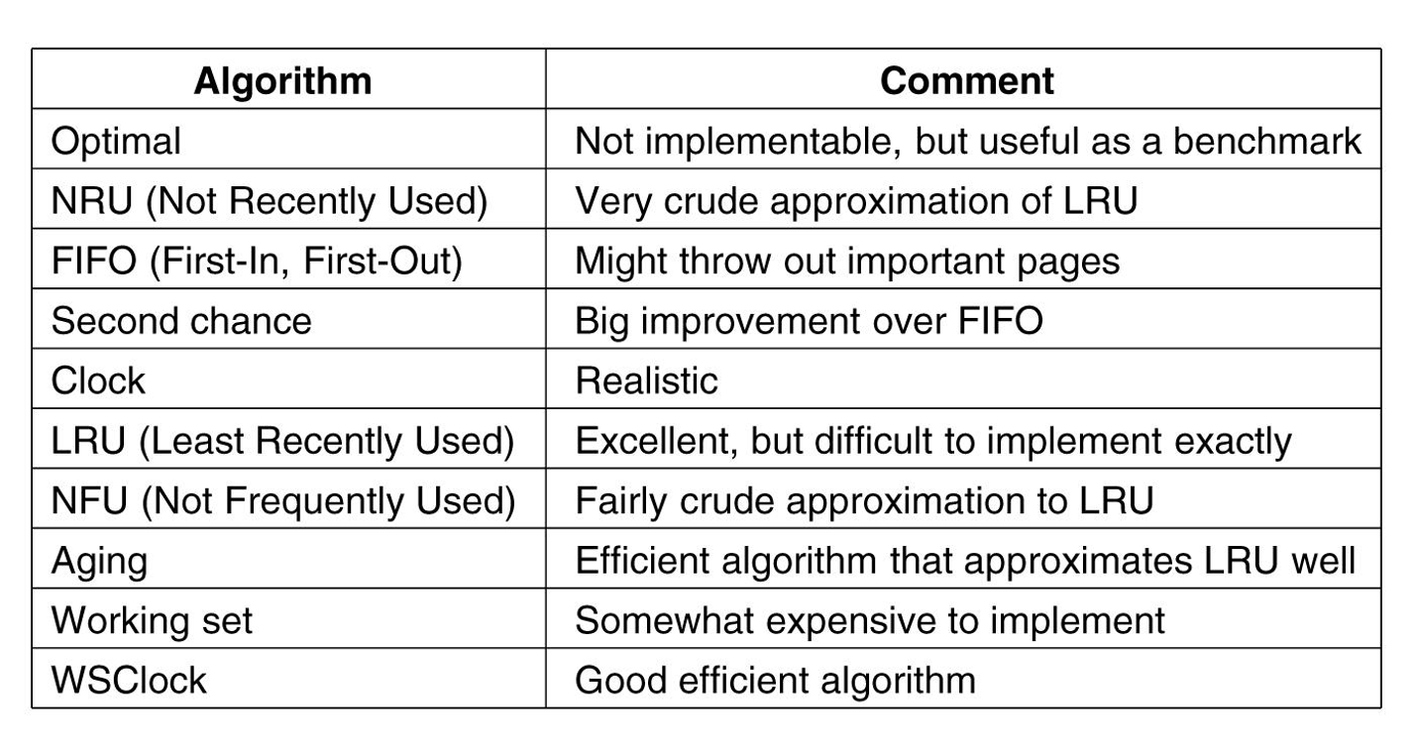

Dispatcher latency: the time it takes for the dispatcher to stop one process and start another running

Some switching:

1. Running -> waiting
2. Running -> ready
3. Waiting -> ready
4. Terminate

If scheduling takes place only under (1) and (4) 🡺 non-preemptive. Else, preemptive.

FIRST COME FIRST SERVED (FCFS)

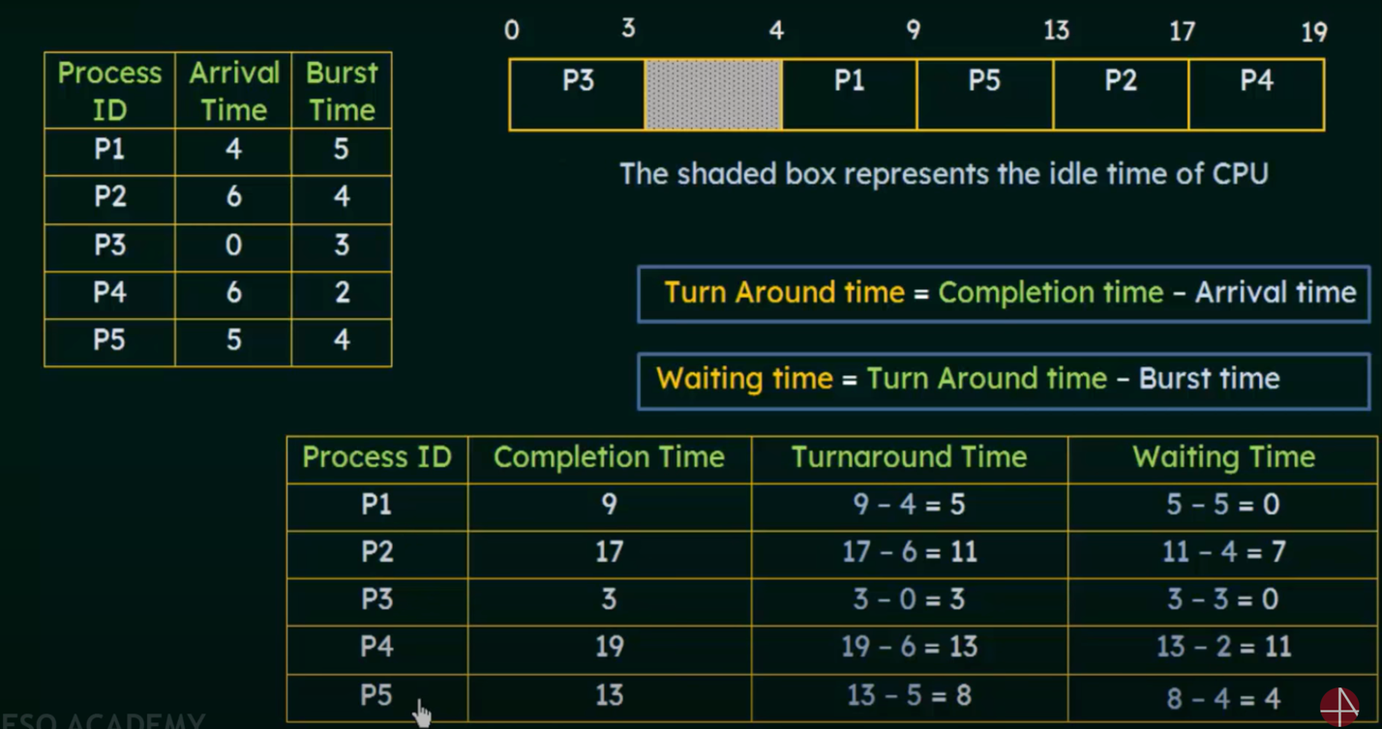

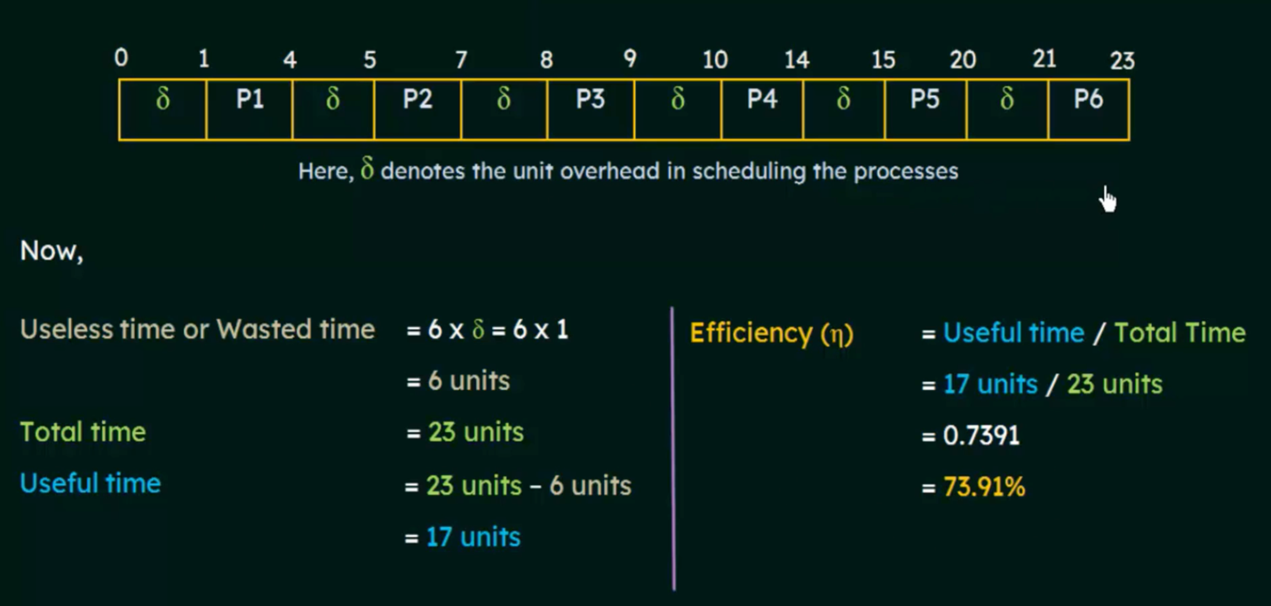

Shortest Job First (preemptive)

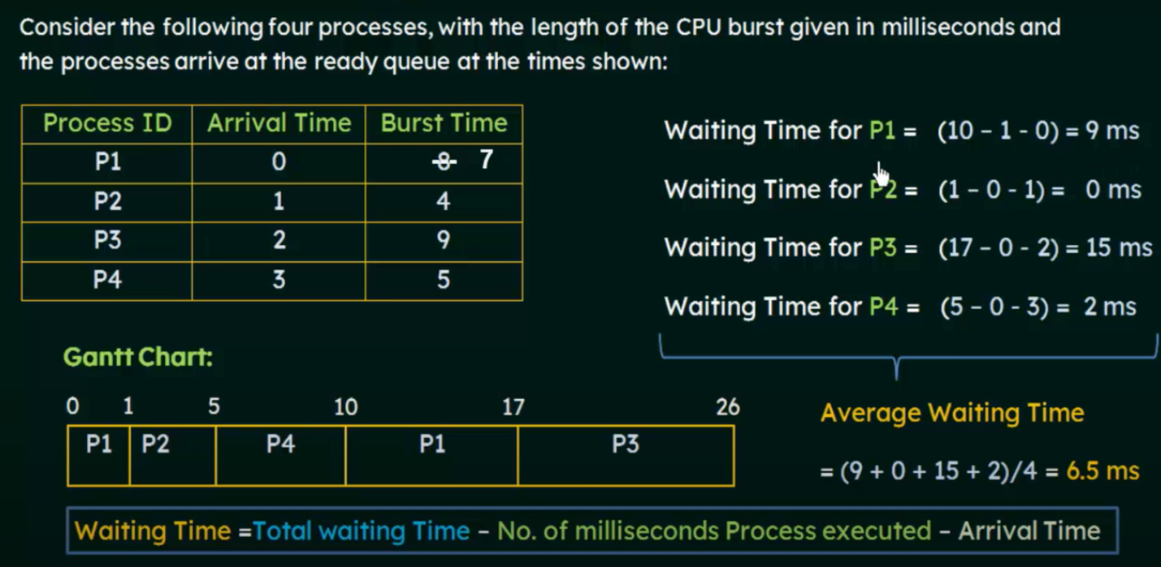

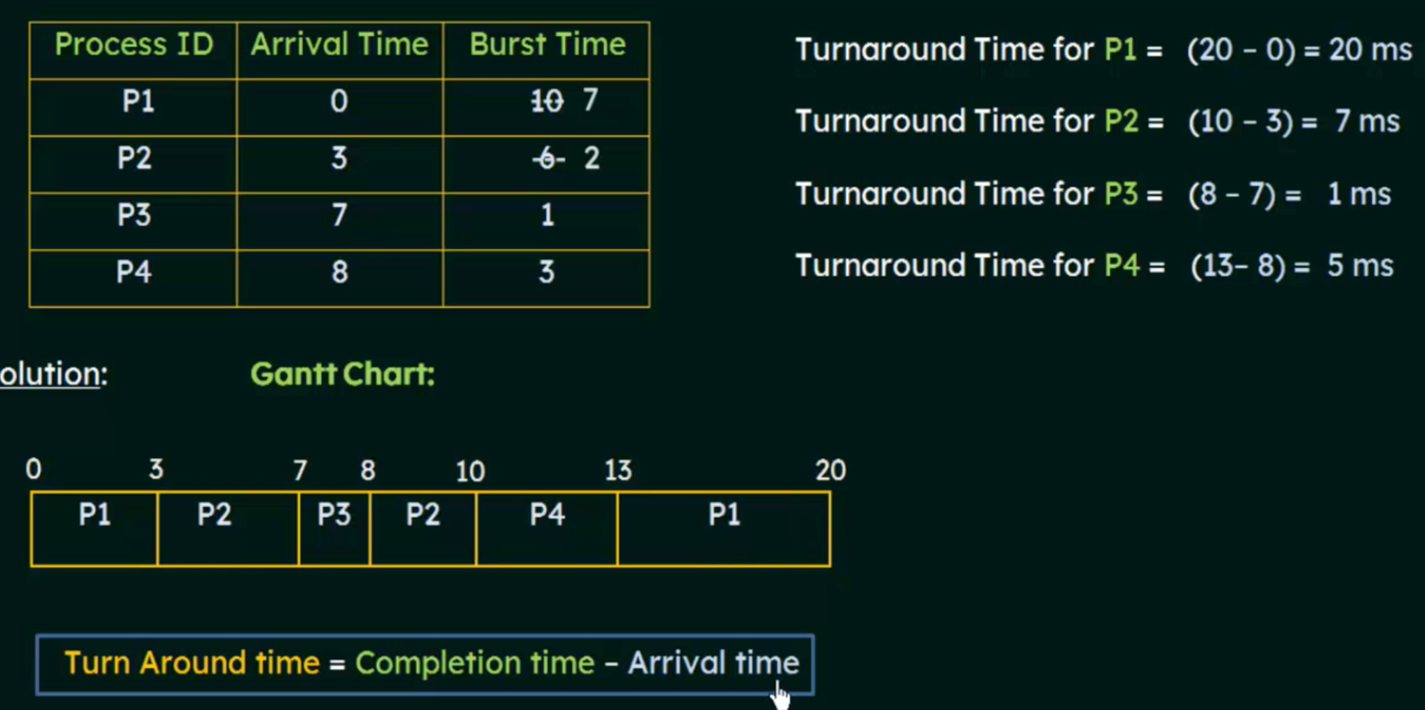

Priority Alogirthm (Non-preepmtive)

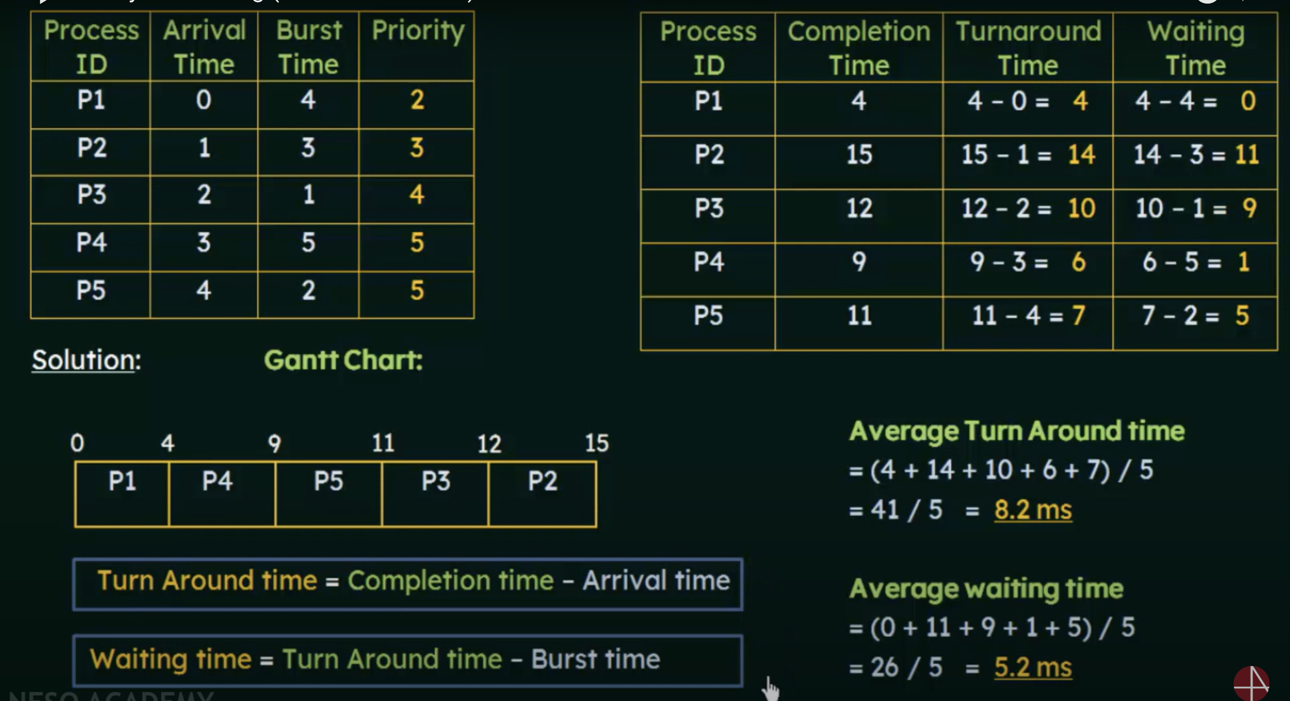

Priority Alogrithm (preepmtive)

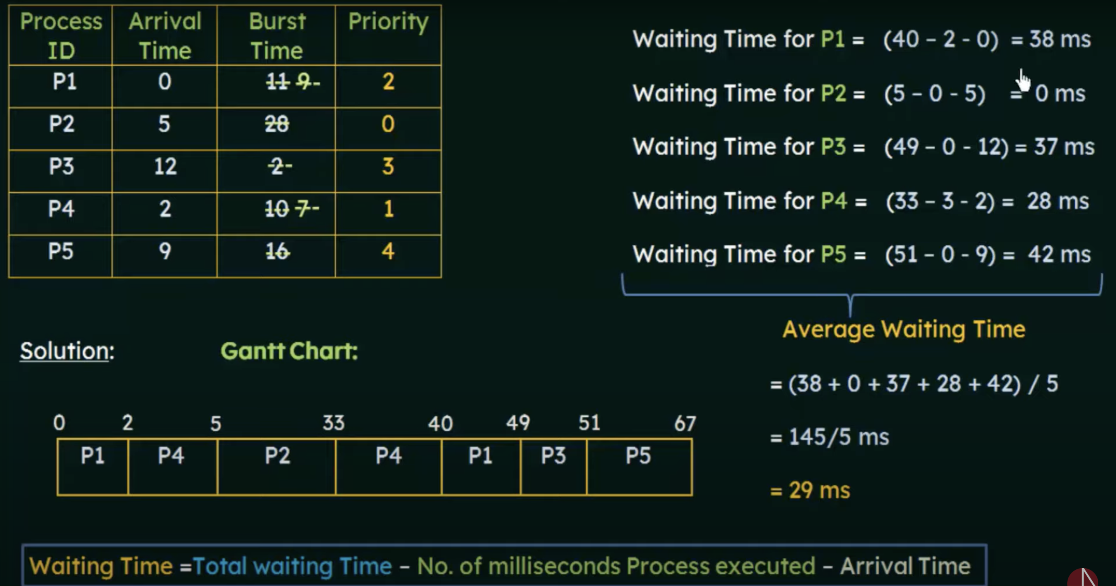Round Robin (non)

